**Security Orchestration & Risk Platform  
Design & Development Plan (DDP)**

From High-Level Design to Execution  
Architecture • Development Roadmap • Compliance

*August 22, 2025*

# 3. Detailed Architecture

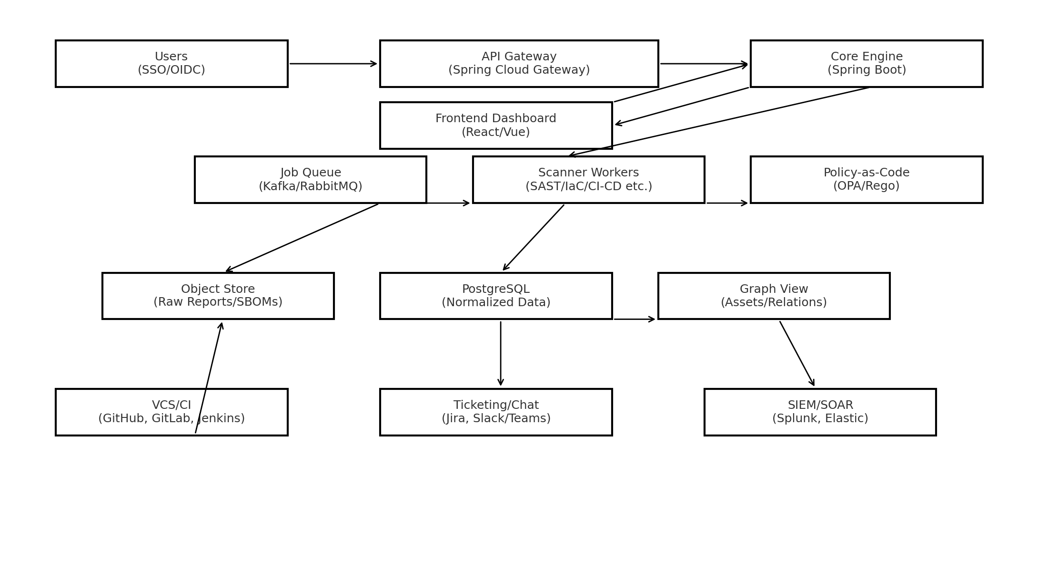

Figure 1: Refined architecture diagram (aligned layers).

# 6. Data Model (Detailed)

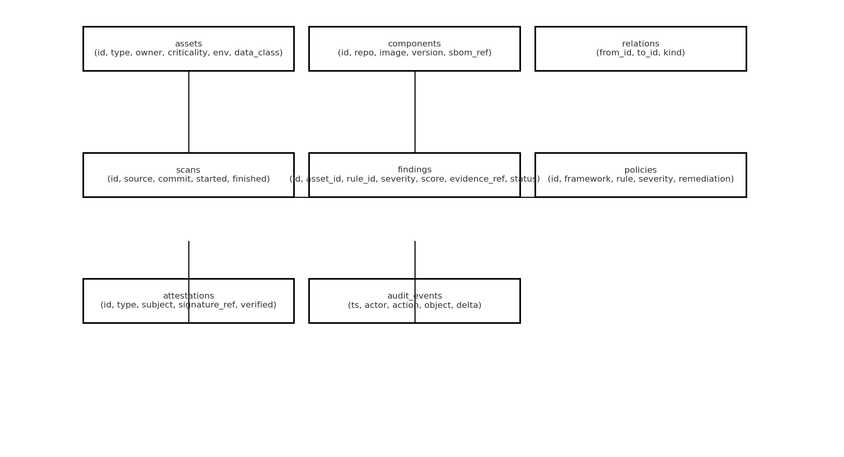

Figure 2: Refined data model diagram with entity relationships.